Computing Project: Report
Name: Daniel Cyril Obon
Student ID: C2650218

Table of Contents
Abstract 4
1. Introduction 5
2. Research and Analysis 7
2.1 Automated Greenhouse Monitoring Systems 7
2.2 Understanding Temperature and Humidity Dynamics 7
2.3 Contrasting Different Machine Learning Models 8
2.3.1 Random Forest (RF) 8
2.3.2 Support Vector Machine (SVM) 9
2.3.3 Extreme Gradient Boosting (XGBoost) 10
2.4 Selecting the XGBoost Machine Learning Model for Climate Prediction 10
2.5 Importance of Machine Learning in Climate Prediction 11
2.6 The Role of User-Friendly Interfaces in Smart Farming 12
3. Project Methodology 13
4. Design 15
4.1 Arduino-Based Monitoring System 15
4.1.1 Hardware Components and Functionality 16
4.1.2 Software Implementation and Data Logging 16
4.1.3 Integration with Python-Based Prediction Model 17
4.2 Greenhouse Monitoring System Python Application 18
4.2.1 Main Menu (main.py) 18
4.2.2 Climate Summary (summary.py) 20
4.2.3 Pressure Forecast (forecast.py) 22
5. Implementation and Testing 24
5.1 Arduino Implementation 24
5.2 Python Implementation: XGBoost Model 24
5.2.1 XGBoost Model Testing: Initial Test 25
5.2.2 XGBoost Model Testing: Adjusted Variables Testing 26
5.3 Python Implementation: Error Handling and Testing 27
6. Critical Evaluation 29
6.1 Arduino Implementation 29
6.2 Python Implementation: XGBoost Model 29
6.3 Python Implementation: Error Handling and Testing 30
6.4 Conclusion 30
6.5 Self Reflection 31
7. References 33

Table 1: Effect of Temperature against Different Plants 7
Table 2: Evaluation Metric Values from Initial Testing 25
Table 3: Evaluation Metric Values After Adjusting Variables Testing 26

Abstract
Ensuring an optimal environmental condition in greenhouses is important for healthy crop growth. However, manual monitoring and adjustment of elements within a greenhouse such as temperature and humidity can be time consuming and inefficient. Thus, this project is investigating an automated greenhouse monitoring system which collects temperature and humidity data using an Arduino and applied machine learning techniques to analyse and predict atmospheric pressure and its trends.
The artefact of this project is two components, an Arduino that continuously records the temperature and humidity data, which then writes them as csv into a microSD card, and a Python application that processes this data by applying the XGBoost machine learning model to predict atmospheric pressure according to the collected data. The Python application features a graphical user interface (GUI) that displays relevant statistics and trends. Moreover, this project undergoes an agile Scrum methodology which ensures that the development of the project is flexible, adaptable and focused, leading to increased productivity.

1. Introduction
Greenhouses are controlled environments for plant growth by allowing farmers and hobbyist to alter and optimize conditions such as temperature and humidity for better crop yield. However, manual climate monitoring is time consuming and impractical, particularly for those with busy schedules or physical limitations.
Recently, advancements in automation and machine learning have made it possible to create smart greenhouse systems that use sensors to gather environmental data and applying predictive analytics to monitor and optimize conditions more effectively, allowing farmers to have more informed climate control decisions. Fernández et al. (2021) reported that the Campo de Dalías region has shown how technological advancements in greenhouse farming have led to environmental benefits such as reduced water and pesticide usage, despite initial issues like habitat loss and groundwater overexploitation. From this, we could propose that by integrating smart monitoring systems with sustainable agricultural practices could lead to optimize resource efficiency and crop yields.
This project looks at creating an automated greenhouse monitoring system that tracks environmental data and uses machine learning to predict atmospheric pressure. It is inspired by the real challenges greenhouse owners, especially older individuals, face when trying to maintain the right conditions for plant growth. With the rise of smart farming and IoT technology in agriculture, this project fits right into the growing trend of using technology to make farming more efficient and accessible. Thus, promoting interest in greenhouse cultivation and contribute to the broader adoption of smart agricultural solutions.
This report details the development of an Arduino-based sensor system for real-time data collection, a Python-based application for data analysis and visualization, and the implementation of the XGBoost machine learning model for atmospheric pressure prediction. Furthermore, an agile Scrum methodology was implemented to ensure iterative improvements, flexibility and adaptability during development.
Therefore, the combination of Arduino, sensors, machine learning integration and a GUI application, this project aims to improve greenhouse climate management by allowing users to make informed decisions for maintaining optimal environmental conditions based on the specific plants they are growing. The proposed project contributes to sustainable agriculture by providing an accessible and efficient solution for farmers, hobbyists, and researchers.

2. Research and Analysis

2.1 Automated Greenhouse Monitoring Systems
Numerous studies have already been conducted to explore the use of automated greenhouse monitoring systems to optimize crop yield. A smart greenhouse system, developed by Saddiqui et al. (2017) which utilizes sensors and actuators to control the temperature, humidity and light intensity has allowed significant improvements in plant growth. Their study demonstrated that automation not only reduces labour but also ensures a controlled microclimate, resulting in a doubling of tomato growth rates compared to traditional outdoor cultivation. This project was built upon an Arduino (microcontroller) and an Ethernet communication module which enables real-time monitoring through a web or Android application, making it accessible for small farms and hobbyists. Moreover, this research has also proposed that the optimal environment condition od 15-30°C for temperature is essential for photosynthesis and plant health. However, while the project does efficiently automate environmental element controls, it does not have any machine learning or predictive modelling implementation, limiting its ability to proactively adapt to fluctuations in climate.

2.2 Understanding Temperature and Humidity Dynamics
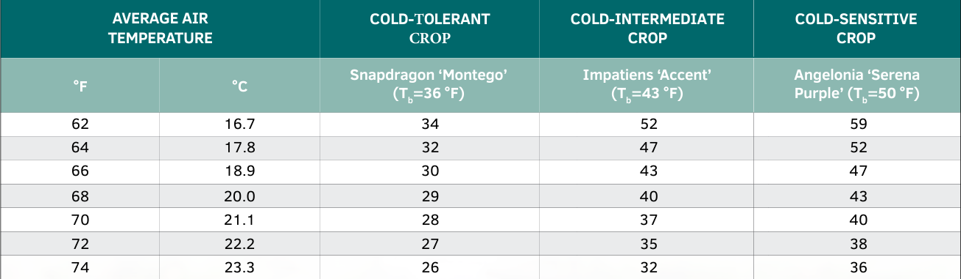
Table 1: Effect of Temperature against Different Plants
Li et al. (2021) has shown the importance humidity in plant growth by exploring various IoT-based greenhouse monitoring methods, which found that variations in humidity significantly affect plant health and crop yield, which in turn displays the importance of accurate monitoring. Similarly, Runkle (2024) also echoes the importance of temperature as it affects the speed of plant development (Table 1), with plants growing faster at higher temperatures and slower at lower ones. Besides that, temperature also affects humidity, as colder air holds less water vapor, leading to higher humidity levels. The combination of these two studies displays the importance of recording temperature and humidity to optimize greenhouse conditions. To further support that temperature and humidity is important data points to be recorded, it was also noticed that warmer air has moisture-holding capacity than cooler air, which implies that with an increase in temperature, the relative humidity decreases (University of Massachusetts Amherst, 2015).

2.3 Contrasting Different Machine Learning Models
There are many different machine learning models to be used in environmental predictions and analysis to optimise the conditions within a greenhouse. Among the most common models implemented in these endeavours are Random Forest (RF), Support Vector Machine (SVM), and Extreme Gradient Boosting (XGBoost). The reason for these models being used are because they are supervised learning models that are known for their ability to handle complex data. However, they differ in approach and performance characteristics, making them suitable for depending on the tasks and its requirements.

2.3.1 Random Forest (RF)
Random Forest (RF), also known as Random Forest Regression is a machine learning model that builds multiple decision trees which combines all their results together to improve prediction accuracy and reduce overfitting. Breiman introduced RF, which uses the bagging technique to generate diverse trees by training them on random subsets of the data. This reduces the correlation between trees, enhancing the model's stability and accuracy (Galiano et al., 2015). RF also helps identify which factors are most important in making predictions, which is useful for understanding how variables such as temperature and humidity affect conditions in a greenhouse. Its ability to handle complex data and still deliver reliable results makes it a great choice for predicting environmental changes.

2.3.2 Support Vector Machine (SVM)
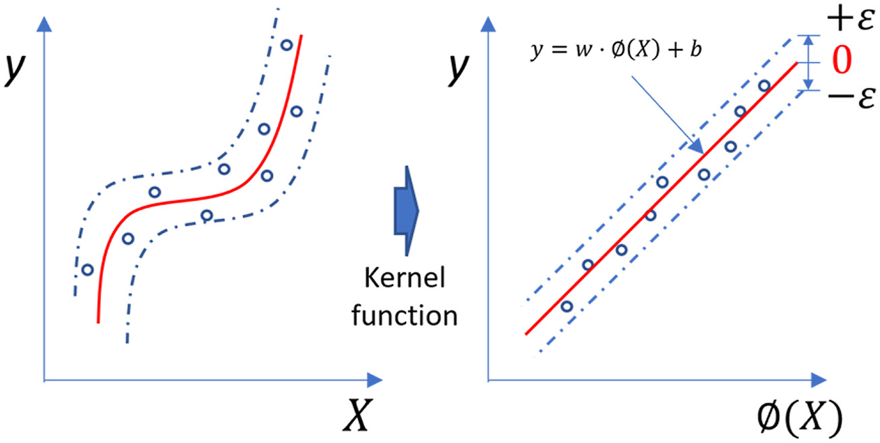
Figure 1: Kernel Function on SVM for Regression

Support Vector Machine (SVM) is a supervised learning model that is developed by Vapnik and Chervonenkis in 1964, that is commonly used in classification and regression. According to Galiano et al. (2015), SVM transforms input data into a higher-dimensional space where it tries to find the best hyperplane to separate or predict values. While SVM is great for handling non-linear data, such as temperature, humidity and pressure, its performance depends a lot on choosing the right kernel function and tuning regularization parameters (Figure 1). Although it’s highly accurate, SVM can be computationally demanding and requires careful parameter tuning, which can make it less practical for real-time applications.

2.3.3 Extreme Gradient Boosting (XGBoost)
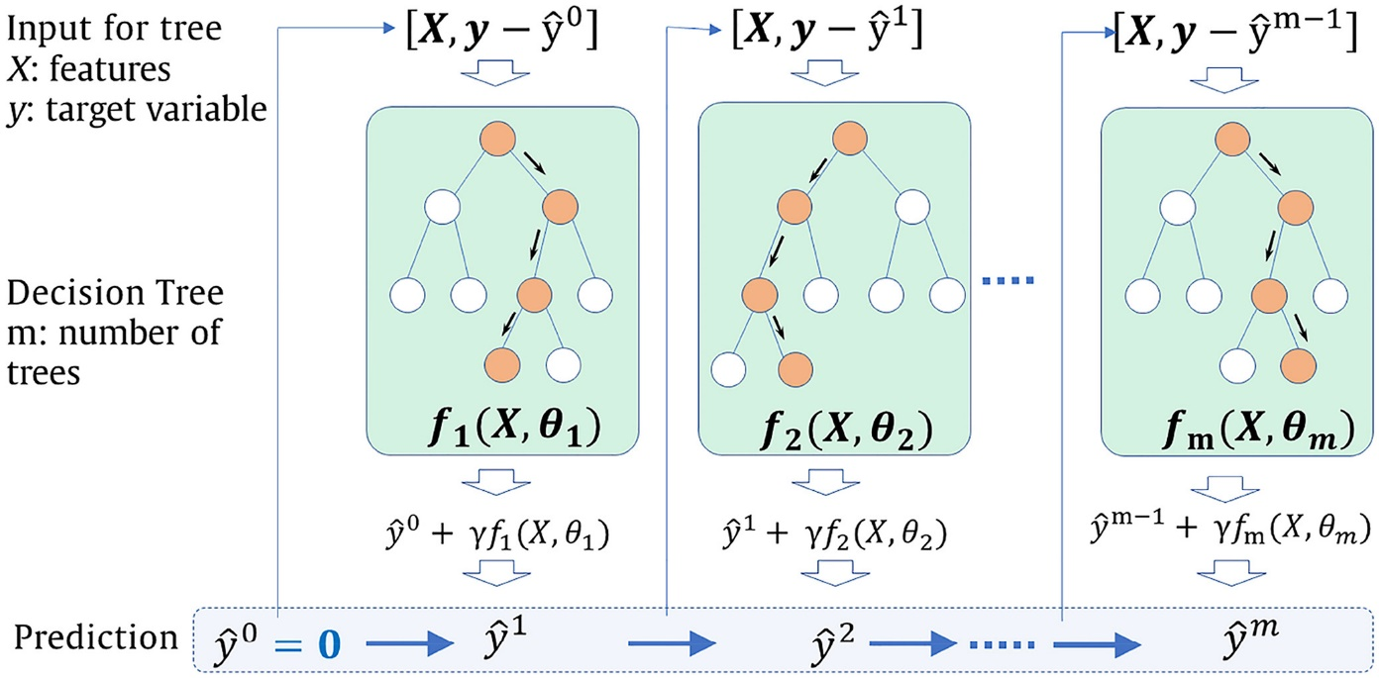
Figure 2: Schematic diagram of GBRT

Extreme Gradient Boosting (XGBoost) is another supervised machine learning model, which was introduced by Chen and Guestrin (2016) as a highly efficient and scalable tree boosting algorithm that has garnered attention in multiple different fields of research. It builds upon the previous Gradient Boosting Regression Trees (GBRT) model by using regularization term to prevent overfitting and improve model performance. XGBoost works by building trees one after another, with each new tree trying to correct the mistakes made by the previous one. This process keeps going until the model is as accurate as possible. The goal is to minimize errors, and it does this by balancing the model’s accuracy with simplicity, adding penalties for overly complex trees to keep things efficient.
XGBoost is effective in predictive modelling due to its ability to handle large datasets efficiently and its use of methods like grid search, random search, and Bayesian optimization to fine-tune its performance, thus leading to its popularity in the field. It has been successfully used in various fields, including environmental and geological predictions, where it has shown high accuracy, especially when dealing with skewed data distributions (Zhu et al., 2021)

2.4 Selecting the XGBoost Machine Learning Model for Climate Prediction
Machine learning has been widely used in climate analysis for prediction. After weighing the pros and cons of each model, XGBoost has shown to be effective and outperforms the other considered algorithms (Random Forest and SVM) in predicting environmental factors such as temperature, humidity and pressure due to its accuracy and stability. Thus, in this implementation has been selected as the machine learning model of choice. The reason for this selection is due to robust nature of XGBoost, being known for its ability to handle complex (non-linear) relationships within the data by using gradient boosting techniques, which reduces bias and variance for higher accuracy predictions. Besides that, XGBoost outperforms Random Forest in terms of computational efficiency as it can be slower to train the more complex the system is as more trees are created. Compared to SVM, XGBoost excels at handling non-linear relationships, while SVM requires careful tuning of the kernel function to achieve similar performance.
While both RF and SVM do offer comparable accuracy in prediction, XGBoost is able to achieve the highest accuracy when tested with datasets that have more environmental features, making the relationship more complex. As such, XGBoost is the preferred choice for atmospheric pressure forecasting in this project. Moreover, XGBoost is more scalable, which is crucial when working with large amounts of data or when seeking to improve model performance over time (Kang et al., 2020).

2.5 Importance of Machine Learning in Climate Prediction
Having a greenhouse monitoring system in concert with intelligent technology such as the implementation of a machine learning model for prediction can significantly improve environmental stability, crop management and resource utilization efficiency. Studies have pointed out that integrating Internet of Things (IoT) to create a smart greenhouse can also lead to reduced energy consumption (Shamshiri et al., 2018). These systems take continuous environmental data by using sensors to track variables such as temperature, humidity and soil conditions, ensuring optimal conditions for plant growth and minimize resource waste. Moreover, advancements in communication technologies, such as ZigBee and NB-IoT have enhanced data transmission within greenhouses, offering more scalable and energy-efficient solutions.
While machine learning (ML) applications in greenhouse monitoring are still emerging, they show great promise for improving predictive capabilities. Shamshiri et al. (2018) highlight the growing potential of ML in climate prediction and control, as it can help predict environmental variables and optimize plant growth conditions based on historical data. The integration of ML with greenhouse systems could lead to smarter decision-making, allowing for more precise control over microclimate factors and ultimately increasing crop productivity while reducing energy and resource consumption.

2.6 The Role of User-Friendly Interfaces in Smart Farming
For agricultural technologies to be widely adopted, ease of use and accessibility are critical factors. Freeman and Robson (2020) emphasized the importance of intuitive user interfaces (UI) in smart farming applications, as poorly designed interfaces can hinder user engagement. This project integrates these insights by designing a simple yet informative GUI that displays temperature, humidity, and pressure trends in an accessible manner.

3. Project Methodology
The methodology that is used for the development of the project is a personal scrum agile methodology, which applies the scrum practices to an individual person project. I have decided to select this methodology as it gives a clear set of goals in each given scrum period/cycle, thus helping in self-motivation by promoting personal productivity through downsizing the project into parts and time-boxing. Besides that, this methodology allows for a more flexible development cycle as it promotes adaptability due to allowing the changing of requirements or unforeseen challenges. Moreover, review documentation on each scrum cycle would be taken at the end of each week, not only for organizational purposes but also to allow retrospective on the cycle and grant user satisfaction.
However, there are some disadvantages that should be mentioned by selecting this methodology. A worry that could be stated is that it prioritizes features over a more robust code base for the application. Due to its time-boxing nature, it incentivises completing a feature in a set amount of time while not allowing much time for the user to optimize the code after. In addition, managing the backlog of features may also prove to be a challenge, as it requires careful organization and prioritization to ensure that essential tasks are not overlooked. Without proper management, there is a risk of accumulating issues, which could affect the long-term sustainability and maintainability of the project.
Therefore, with the advantages and disadvantages stated, it could be said that the advantages outweigh the disadvantages with proper planning. As such to mitigate these challenges, I plan to regularly review the backlog, reassess priorities, and allocate time for refactoring when necessary.
For the data usage aspect, a sample dataset “Daily climate in Delhi. ARIMA with TimeSeries” from Kaggle (Georgy Zubkov, 2017) would be used that includes the temperature and humidity of a given environment. If time permits, I will also create my own dataset using the project in my own greenhouse. This personalized dataset will not only validate the findings from using the Kaggle dataset but also provide valuable insights specific to the conditions of my greenhouse, ultimately contributing to a more effective monitoring solution.
The artefact of this project consists of three main components, an Arduino-based hardware system, a Python application with a graphical user interface (GUI), and Arduino logic code for data collection and processing. The sensors that accompany the Arduino for data collection and logging are a DHT11 sensor to measure temperature and humidity, and a microSD card module to store logged data. Besides that, the Arduino logic code is written in Arduino C, which is responsible for looping the environmental data collection at fixed intervals (10 minutes) and logs the readings into a CSV file called DATA.csv. This code will also have forms error-handling to prevent data loss due to sensor failures or SD card issues. The data collected is then used and trained in the Python application to predict atmospheric pressure trends using the XGBoost model.
The Python application acts as the primary platform for analysing and visualizing the collected data. Developed using PyQt5 for the GUI, it integrates machine learning models, specifically an XGBoost-based regression model, to predict atmospheric pressure based on temperature and humidity inputs. The application processes the recorded CSV data, calculates key statistics (such as average, highest, and lowest recorded values), and visualizes trends through interactive graphs. Additionally, it provides features for converting temperature units and plotting pressure predictions based on temperature and humidity variations. This integrated approach ensures a seamless connection between hardware and software, allowing for efficient environmental monitoring and pressure prediction while maintaining flexibility for future enhancements.

4. Design

4.1 Arduino-Based Monitoring System
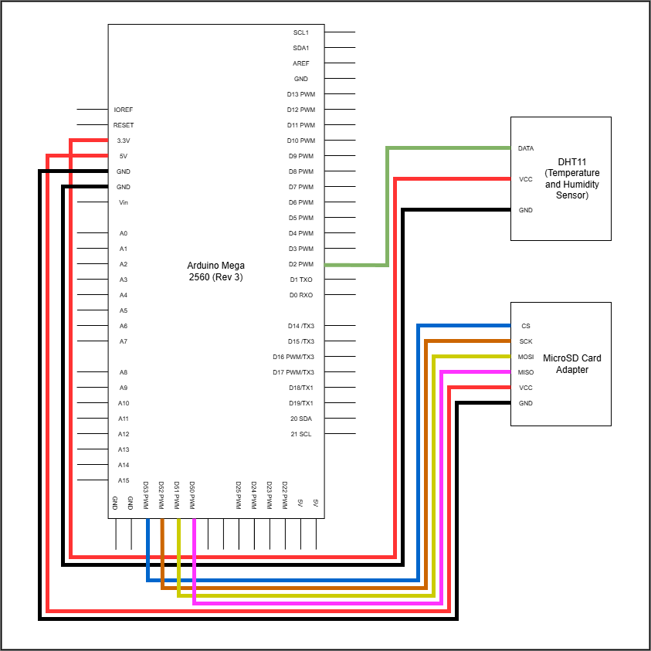
Figure 3: Circuit Diagram of the Arduino-Based Monitoring System

Figure 3 illustrates the hardware components and their connections of the Arduino-Based Monitoring System. It is designed to continuously measure and record temperature and humidity, providing essential environmental data for predicting atmospheric pressure. These data are then written into a microSD card as a CSV file, which can later be processed and analysed by a Python-based application for atmospheric pressure prediction. This system consists of both hardware (Arduino and sensors) and software (Arduino C language), working together to ensure efficient data collection and storage.

4.1.1 Hardware Components and Functionality
This project uses an Arduino Mega 2560 (Rev 3) as the microcontroller for data collection and logging. To collect the environmental data that is to be used for prediction, a DHT11 sensor is used to measure them. Besides that, it provides reliable readings for its cost, making it well-suited for greenhouse and environmental monitoring applications within the scope of this project.
The collected data (temperature and humidity) is stored in a microSD card through microSD card module, which then could also be tracked in real-time by using the SPI (Serial Peripheral Interface) protocol on the Arduino IDE. In addition, the microSD card (32GB) allows for long-term data logging, which is then used for the Python application of this project to predict atmospheric pressure trends according to the data collected. Powering the Arduino is a 9V battery, which makes the project more portable and eliminates the need for a constant connection to an electrical outlet. Thus, making it suitable for remote locations that do not have access to power sources.

4.1.2 Software Implementation and Data Logging
The system's software is implemented using the Arduino C programming language, controlling the data collection and storage processes. The setup phase initializes the SD card and checks for proper communication between the microcontroller and the storage module. If the SD card is successfully initialized, the system creates a CSV file (if it does not already exist) with a header line defining the recorded parameters: temperature and humidity.
During operation, the system logs the data every 10 minutes, collecting temperature and humidity values using the DHT11 sensor. The decision to log data at this interval is based on the need to balance between obtaining sufficient data for analysis and conserving battery life, as the system runs on a 9V battery. A 10-minute interval reduces power consumption while still capturing meaningful environmental changes, which occur gradually in a greenhouse setting. The collected data can be displayed in real-time on the Arduino IDE’s serial monitor and simultaneously written to the microSD card. Each entry in the CSV file follows a structured format where temperature and humidity readings are separated by commas. If an error occurs in writing to the SD card, the system outputs a failure message, ensuring reliability in data logging.

4.1.3 Integration with Python-Based Prediction Model
The stored data from the microSD card is later processed by a Python application that applies the XGBoost machine learning model to predict atmospheric pressure based on historical temperature and humidity readings. By leveraging environmental data, the system enhances forecasting capabilities, making it useful for applications such as greenhouse monitoring and climate research.
The model is used to analyse and predict trends on atmospheric pressure according to temperature and humidity which is useful for optimizing plant growth, though the user must do their due diligence on knowing the optimal temperature and humidity requirements for their specific plants.
This automated monitoring and predictive system reduces the need for manual measurements, improves data accuracy, and offers a scalable solution for environmental monitoring applications.

4.2 Greenhouse Monitoring System Python Application

4.2.1 Main Menu (main.py)
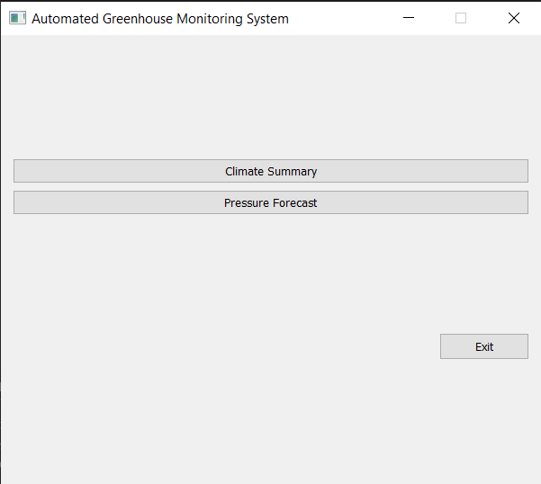
Figure 4: Main Menu GUI

The main menu (Figure 4) is the initial window PyQt5 graphical user interface (GUI) that appears for the user when running the greenhouse monitoring system application, showing the available option buttons describing their functionalities. The two main buttons being, "Climate Summary" and "Pressure Forecast". These buttons allow the user to navigate to different windows for viewing the greenhouse's climate data or the predicted atmospheric pressure according to temperature and humidity.
- Window Layout and Design: The main window is centred on the screen and has a fixed size, and the window layout is organized using QVBoxLayout and QHBoxLayout. Thus, ensuring a user-friendly UI due to its simplicity.
- Functionality: When the "Climate Summary" button is clicked, it opens the Climate Summary window that is ran by summary.py, which displays the relevant statistics about the temperature and humidity data collected. When the "Pressure Forecast" button is clicked, it opens the Pressure Forecast window which is handled by forecast.py to show predicted pressure trends as well as the statistics of the machine learning model used (XGBoost). Additionally, an "Exit" button is available to close the application.

4.2.2 Climate Summary (summary.py)
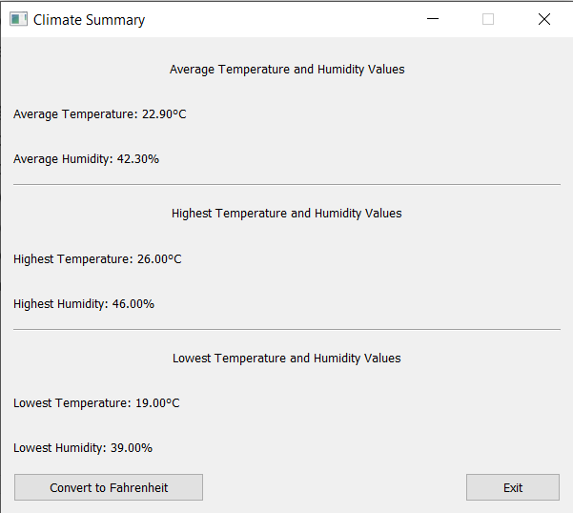
Figure 5: Climate Summary GUI

The Climate Summary window (Figure 5) provides an overview of the temperature and humidity data collected by the Arduino and its sensors. It displays relevant statistics such as the average, highest, and lowest temperature and humidity values from the DATA.csv file which is written by the Arduino into the microSD card.
- Data Handling: The Python application reads data from DATA.csv, which processes and displays relevant statistics on the window. It searches for the average, highest, and lowest values for both temperature and humidity, updating the labels on the window.
- Unit Conversion: A button that allows users to toggle between Celsius and Fahrenheit for temperature measurements is implemented. When button is clicked, the displayed values are then automatically updated and converts the values to the appropriate measurement unit. This feature makes the application more accessible by allowing users from different regions suit their preferred unit of measurement, making the system more versatile for users worldwide.
- Error Handling: If an issue was encountered when reading the data, such as a missing file or invalid data, an appropriate error message is displayed on the screen depending on the error. This ensures that users are informed of any file related issues.

4.2.3 Pressure Forecast (forecast.py)
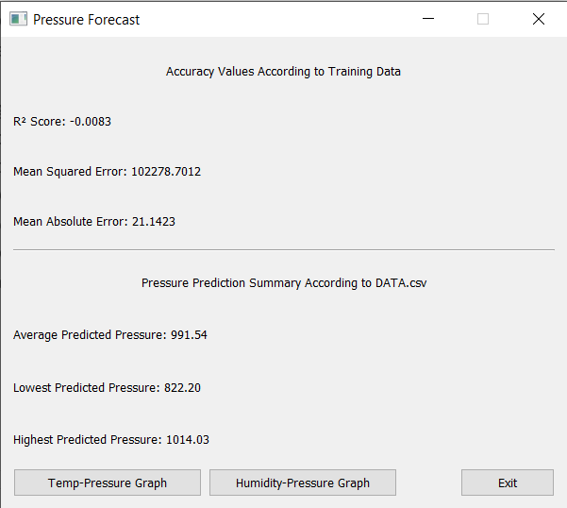
Figure 6: Pressure Forecast GUI

The Pressure Forecast window (Figure 6) is responsible for displaying statistics about the predicted atmospheric pressure based on temperature and humidity values. The application uses the XGBoost machine learning model to forecast pressure, trained on a dataset obtained from Kaggle containing daily temperature, humidity, and pressure.
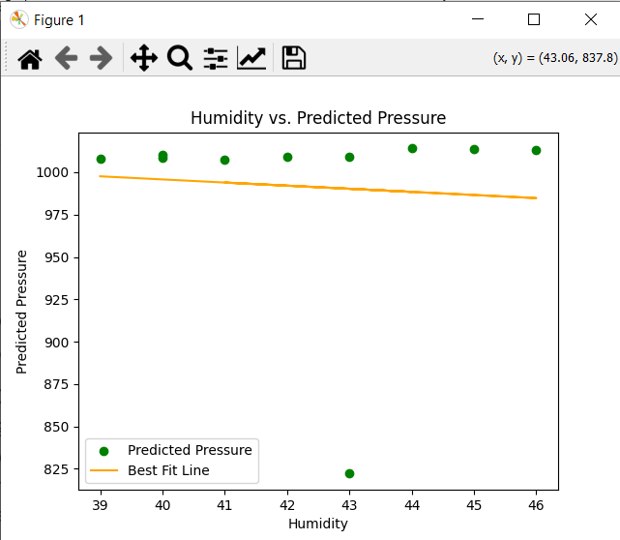
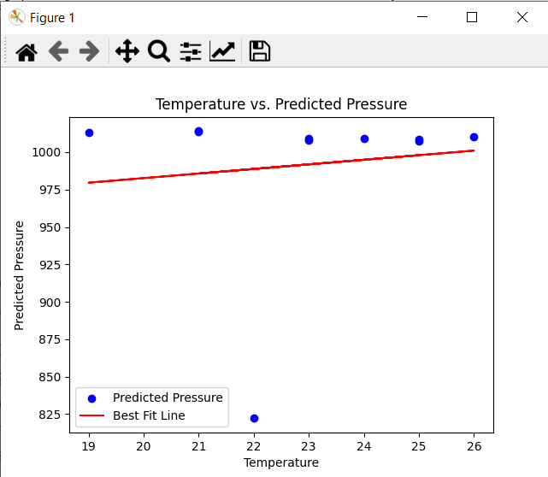
- Machine Learning Model: The XGBoost machine learning model is implemented to train on historical data from Kaggle (DailyDelhiClimateTrain.csv) to predict atmospheric pressure based on the data recorded in the DATA.csv file. The performance of this model is then displayed on the window using key metrics, such as R², Mean Squared Error (MSE), and Mean Absolute Error (MAE). These metrics are important in determining the accuracy of the model’s predictions. The R² value indicates how well the model’s predictions match the actual data, while MSE and MAE provide insights into the model’s error margins/deviation, with lower values generally representing more accurate predictions.
Figure 8: Humidity and Predicted Pressure Graph
Figure 7: Temperature and Predicted Pressure Graph

- Graphical Visualization: The Pressure Forecast window has two buttons that generate graphs which show the relationship between temperature and pressure (Figure7), as well as humidity and pressure (Figure 8), with a best-fit line. These visualizations help users understand the correlation between environmental factors and the predicted pressure.
- Data Handling: The application reads the training (DailyDelhiClimateTrain.csv) and test data (DATA.csv) and fits the model using XGBoost to makes predictions that are then displayed on the GUI. The predicted pressure values are summarized with their average, highest, and lowest values.

5. Implementation and Testing

5.1 Arduino Implementation
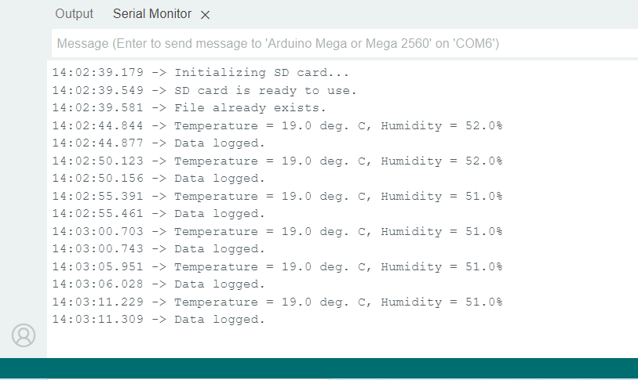
Figure 9: Console Display of Data Logging

The Arduino operates autonomously in an infinite loop to gather temperature and humidity data using the DHT11 sensor. These data points are then logged and written into a microSD card in 10-minute intervals for further analysis. The implementation of this system ensures that real-time environmental data is captured and stored, which serves as the input for a Python application for later predictions regarding atmospheric pressure. To test the system, the Arduino IDE is used (Figure 9), with the console serving as proof that the readings are being successfully transmitted. The console displays real-time temperature and humidity data, confirming that the sensor readings are being properly captured before being written to the microSD card.

5.2 Python Implementation: XGBoost Model
To predict the atmospheric pressure according to the temperature and humidity data collected, the XGBoost-based model was selected as the machine learning model of choice to be used in the Python application. The model was initially tested in the XGBoost_Research.py script, which implements the ‘scikit-learn’ library. The dataset used for training the model is the climate dataset DailyDelhiClimateTrain.csv which includes temperature, humidity, and the corresponding pressure readings. After the successful testing of this model, it is then implemented into the main application under forecast.py, which is responsible for displaying graphical trends of the predicted atmospheric pressure according to the data from DATA.csv.
Key steps in the model implementation include:
- Data Preprocessing: The dataset is loaded, and relevant columns (meantemp and humidity) are selected as the features, while the target variable is meanpressure.
- Train-Test Split: The data is divided into training and testing sets to evaluate model performance accurately.
- Model Training: An XGBoost Regressor is initialized and trained on the training data.
- Model Testing: Predictions are made on the test data, and evaluation metrics such as Mean Squared Error (MSE), Mean Absolute Error (MAE), and R-squared are computed.
- Results: The model’s performance is evaluated, and the results are saved in a CSV file for further analysis.

5.2.1 XGBoost Model Testing: Initial Test
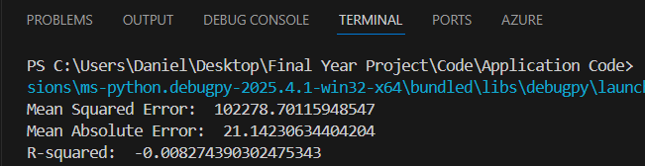
Figure 10: Console Display of Initial Test Values

The evaluation metrics for the model's performance when predicting atmospheric pressure using temperature and humidity yielded the following results (Table 2):
Mean Squared Error (MSE) | 102278.70
Mean Absolute Error (MAE) | 21.14
R-Squared Value | -0.008 (-0.8%)
Table 2: Evaluation Metric Values from Initial Testing
These results suggest that the model was not able to effectively capture the variance in the meanpressure. A negative R-squared indicates that the model performed worse than a simple mean-based prediction, while the high MSE shows that the model's predictions were not well fitted to the data. Despite this, the MAE was relatively low, indicating that the predictions didn’t deviate too much from the actual values.
The showing of a negative R-squared value can be attributed to the lack of a strong correlation between temperature, humidity in predicting atmospheric pressure in this specific dataset. This could suggest that atmospheric pressure is influenced by a more complex set of factors, and relying on just temperature and humidity for prediction may not yield highly accurate results.

5.2.2 XGBoost Model Testing: Adjusted Variables Testing
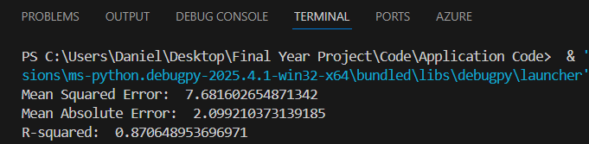
Figure 11: Console Display of Test Values After Adjusting Variables

A different set of variables are then used for testing to investigate the impact on the model performance, the features were changed. Instead of using temperature and humidity to predict atmospheric pressure, the new model was trained to predict temperature using pressure and humidity as the features. The following evaluation metrics were obtained for this model (Table 3):
Mean Squared Error (MSE) | 7.68
Mean Absolute Error (MAE) | 2.10
R-Squared Value | 0.87 (87%)
Table 3: Evaluation Metric Values After Adjusting Variables Testing
These results show a significant improvement in model performance, particularly in terms of the R-squared value (0.87), which shows that the model was able to capture 87% of the variance. The MSE and MAE values were also much lower compared to the previous model, suggesting that the predictions were much closer to the actual values. Thus, this implies that pressure and humidity have a stronger relationship to predict temperature, compared to other variables previously considered.

5.3 Python Implementation: Error Handling and Testing
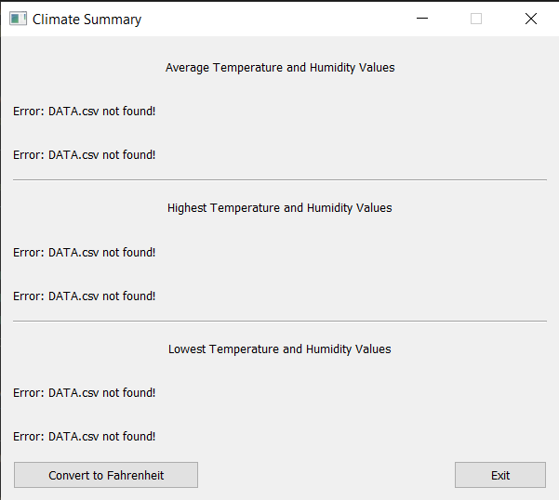
Figure 12: Error Display when DATA.csv File is Missing in Data Directory

During the implementation of the project, I also tested the error-catching capabilities of the code. To ensure that application is robust and could handle missing or incorrect data, I removed certain CSV files and observed how the program responded. When attempting to read the dataset, the program correctly raised an error and displayed an appropriate message on the screen. This error-handling feature was implemented using try-except blocks in both the summary.py and forecast.py. For example, in forecast.py, if a required column is missing in the dataset, a ValueError is raised, and the corresponding error message is printed. Similarly, if the DATA.csv file is not found in summary.py, an error message is displayed, indicating the missing file. This error testing helped confirm that the application could gracefully handle potential data issues and provide useful feedback to the user.

6. Critical Evaluation

6.1 Arduino Implementation
Several flaws have been realized that could be improved upon in the future to enhance reliability of the hardware in outdoor environments. One such flaw is the Arduino’s battery life. The current power source is a 9V battery, which may not provide sufficient power for long-term use and would require frequent replacements or recharges. An improvement that could be implemented would be to connect the Arduino to a stable power outlet instead of relying on a battery. Using an AC adapter to ensure a continuous and reliable power source, eliminating the need for frequent battery changes and allowing the system to operate without interruptions. However, this does mean that the area where this project is used must have an electrical outlet to support this need.
Besides that, the lack of visual display is another issue. This design decision is unfriendly to users as they cannot easily monitor the temperature and humidity in real time without inserting the microSD card into a PC for analysis, as it is inconvenient for those who require immediate feedback on the environmental conditions. As such, an LCD screen could be added to the Arduino, enabling users to view the current temperature and humidity directly without the need of external devices.
Addressing these flaws would improve energy efficiency, and user experience of the automated greenhouse monitoring system, making it more suitable for long-term outdoor use.

6.2 Python Implementation: XGBoost Model
The improved performance of the XGBoost model when the target and input variables were switched can be attributed to the stronger relationship between the features (pressure and humidity) and the target variable (temperature). The original approach, which used temperature and humidity to predict mean pressure, showed a negative R-squared value and an unusually high MSE, indicating that the model was unable to capture the underlying patterns in the data effectively. As such it could be proposed that pressure and humidity likely have a more direct influence on mean temperature than the inverse relationship between temperature and pressure. This emphasizes the significance of choosing the right features to improve the accuracy of predictions.
Therefore, future iterations should use more environmental factors, such as wind speed to improve the models’ accuracy. The flexibility of the XGBoost model allows for such adjustments, making it a promising tool for further experimentation and optimization.

6.3 Python Implementation: Error Handling and Testing
While the implemented error-handling using try-except blocks in summary.py and forecast.py ensures that missing files or incorrect data are handled gracefully, there are some limitations to this way of testing. The current method is primitive as it just prints simple error messages, which is useful for debugging but may not be the most efficient way to handle errors.
A more effective approach would be to implement dedicated test scripts using a testing framework such as pytest or unittest. These test scripts could automatically run checks on each function, ensuring that missing files, incorrect data formats, and other potential issues are caught consistently. This method would provide a more reliable and scalable way to verify the error-handling capabilities of the system over time.
By implementing these improvements, the error-handling process could become more structured, efficient, and adaptable to different failure scenarios.

6.4 Conclusion
This project successfully met its objectives by developing an automated greenhouse monitoring system and that uses machine learning model (XGBoost) for climate prediction. The system effectively collected temperature and humidity data, stored it on a microSD card, and used it for further analysis in a Python application with GUI capabilities. Numerous research questions were explored such as the relationships between temperature, humidity, and atmospheric pressure, performances of multiple different machine learning models. From testing, it was found pressure and humidity were more effective predictors of temperature, emphasizing the importance of carefully selecting relevant input variables in machine learning models.
The methodology uses both hardware and software elements. The Arduino system was developed with real-time data collection and the machine learning model was implemented into the Python application. Although the core implementation was successful, the project has areas of improvement, such as the limited battery life of the Arduino, and lack of real-time display. Addressing these issues would significantly enhance the practicality of the monitoring system for long-term outdoor use.
One of the key learning points from this project was the importance of feature selection in machine learning. The initial approach of predicting mean pressure using temperature and humidity resulted in poor performance, highlighting how different environmental variables contribute to climate conditions in complex ways. This insight will be valuable for future work in data-driven predictions and sensor-based applications. Another major takeaway was the significance of robust system design in hardware projects, particularly when developing systems intended for real-world deployment. Future iterations could incorporate a power outlet source instead of relying solely on a battery, a weatherproof enclosure to protect components, and a display for real-time data access.
If I were to do this project in the future, I would put greater importance on testing and validation. Implementing unit tests for Python scripts. Further development of this project could explore integrating additional environmental sensors, such as wind speed and soil moisture, to create a more comprehensive climate monitoring system. Expanding the dataset with external meteorological data could also improve prediction accuracy. On the hardware side, adding wireless connectivity to transmit data in real-time rather than relying solely on SD card storage would make the system more dynamic and accessible.

6.5 Self Reflection
This project has made me more interested in both hardware and machine learning applications. The combination of hardware and software development provided valuable experience in real-world data collection with predictive analytics. In the future this will help my career decisions, particularly in areas involving IoT, automation, and AI-driven environmental monitoring. The project has highlighted the importance of both theoretical knowledge and practical implementation, and I look forward to refining and expanding these skills in future work.
Moreover, this experience has also helped me grow on a personal level as managing both the hardware and software aspects required patience, persistence, and adaptability, teaching me how to approach challenges methodically rather than rushing to find quick solutions. More importantly, it has made me more discipline in how I manage my time and structure my work. I have learned to set clear goals, manage my workload efficiently, and stay focused on tasks without unnecessary distractions. These skills have not only made me more productive in this project but will also benefit me in future technical work and any professional role that requires independent problem-solving and time management.

7. References
Blum, J. (2019) Exploring Arduino: Tools and Techniques for Engineering Wizardry. 2nd Edition. Indianapolis: Wiley.
Chen, T. and Guestrin, C. (2016). ‘Xgboost: A scalable tree boosting system’, Proceedings of the 22nd acm sigkdd international conference on knowledge discovery and data mining (pp. 785-794).
ELEGOO (2024) ELEGOO Mega 2560 the Most Complete Starter Kit Tutorial. Available at: https://www.elegoo.com/en-gb/blogs/arduino-projects/elegoo-mega-2560-the-most-complete-starter-kit-tutorial?srsltid=AfmBOoqi5TNNmHabMT6Pf5ucZwCktYBKg3AazW6EX0sUU8CxF47Ux7P5 (Accessed: 18 October 2024)
Freeman, E. and Robson, E. (2020) Head First Design Patterns: Building Extensible & Maintainable Object-Oriented Software. 2nd Edition. Beijing: O'Reilly Media, Inc.
Georgy Zubkov (2017) Daily climate in Delhi. ARIMA with TimeSeries. Available at: https://www.kaggle.com/code/georgyzubkov/daily-climate-in-delhi-arima-with-timeseries/input (Accessed: 18 October 2024)
Kang, Y., Ozdogan, M., Zhu, X., Ye, Z., Hain, C. and Anderson, M. (2020). ‘Comparative assessment of environmental variables and machine learning algorithms for maize yield prediction in the US Midwest’, Environmental Research Letters, 15(6), p.064005.
Li, H., Guo, Y., Zhao, H., Wang, Y. and Chow, D. (2021). ‘Towards automated greenhouse: A state of the art review on greenhouse monitoring methods and technologies based on internet of things’, Computers and Electronics in Agriculture, 191, p.106558.
Mendoza-Fernández, A.J., Peña-Fernández, A., Molina, L. and Aguilera, P.A. (2021). ‘The role of technology in greenhouse agriculture: Towards a sustainable intensification in Campo de Dalías (Almería, Spain)’, Agronomy, 11(1), p.101.
Rodriguez-Galiano, V., Sanchez-Castillo, M., Chica-Olmo, M. and Chica-Rivas, M.J.O.G.R. (2015). ‘Machine learning predictive models for mineral prospectivity: An evaluation of neural networks, random forest, regression trees and support vector machines’, Ore geology reviews, 71, pp.804-818.
Runkle, E. (2024) Controlling greenhouse temperature for successful production. Available at: https://www.canr.msu.edu/floriculture/uploads/files/Production%20temperature.pdf (Accessed: 18 October 2024)
Shamshiri, R.R., Jones, J.W., Thorp, K.R., Ahmad, D., Man, H.C. and Taheri, S. (2018). ‘Review of optimum temperature, humidity, and vapour pressure deficit for microclimate evaluation and control in greenhouse cultivation of tomato: a review’, International agrophysics, 32(2), pp.287-302.
Siddiqui, M.F., Kanwal, N., Mehdi, H., Noor, A. and Khan, M.A. (2017). ‘Automation and monitoring of greenhouse’, 2017 International Conference on Information and Communication Technologies (ICICT) (pp. 197-201).
University of Massachusetts Amherst (2015). UMass Extension Greenhouse Crops and Floriculture Program. Available at: https://ag.umass.edu/greenhouse-floriculture/fact-sheets/reducing-humidity-in-greenhouse (Accessed: 18 October 2024)
Zhu, X., Chu, J., Wang, K., Wu, S., Yan, W. and Chiam, K. (2021). ‘Prediction of rockhead using a hybrid N-XGBoost machine learning framework’, Journal of Rock Mechanics and Geotechnical Engineering, 13(6), pp.1231-1245.

